Project Demo Planning
Project Demonstration
Date | 17 July 2026
Team ID | Not provided
Project Name | House Rent Management System (HouseHunt / RentEase)
Maximum Marks | 1 Mark

Section | Description | Duration | Suggested Presenter
Introduction | Problem, users, and project goal | 2 min | Duvva Naveen
Architecture | React, Express, MongoDB, JWT, and uploads | 3 min | Team member
Renter flow | Register/login, browse/filter, submit booking | 4 min | Team member
Owner flow | Approval, property CRUD, booking status | 4 min | Team member
Admin flow | Owner approval and platform views | 3 min | Team member
Quality | Known issues, testing plan, and future work | 2 min | Team member
Q&A | Answer evaluator questions | 5 min | All members

Demo Flow
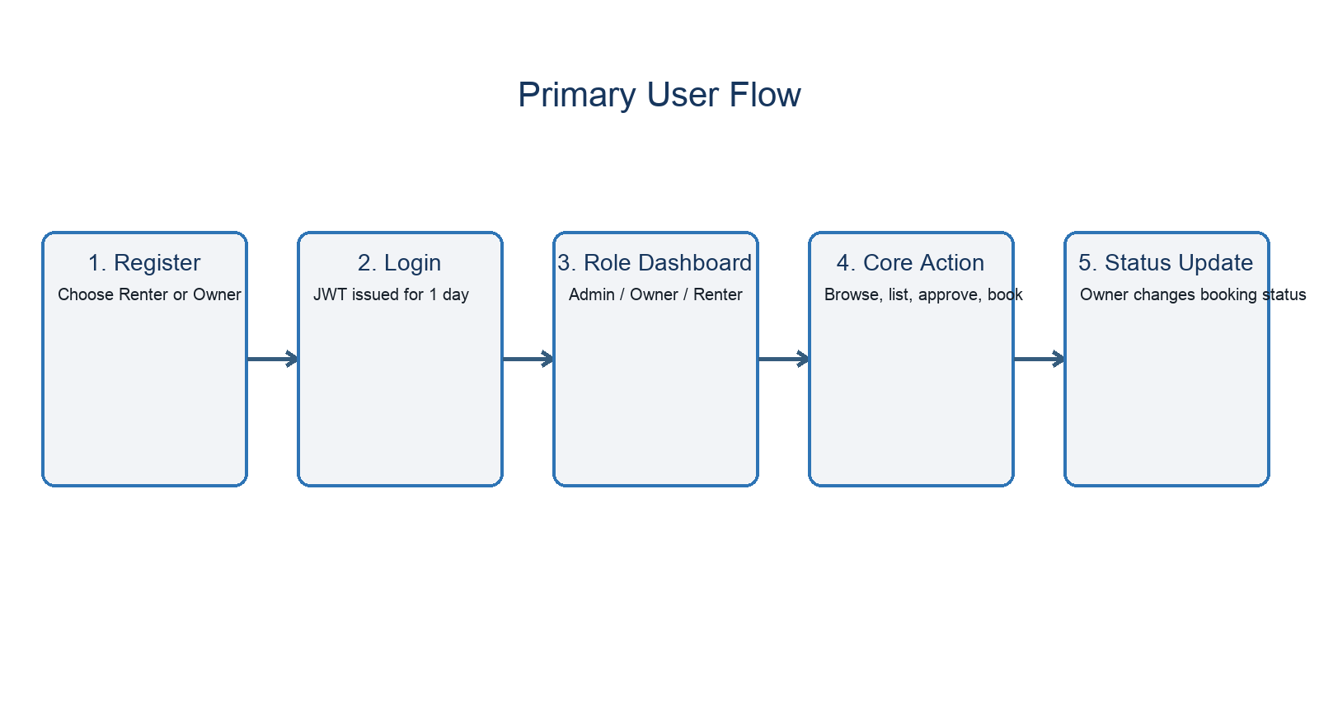
Submission note: Team ID and any member-specific role allocation should be confirmed before final academic submission.

